# 1. Introduction

Urbanization is one of the most important anthropogenic activities (Qiu et al. 2020; Chu et al. 2017; Kalnay and Cai 2003). Correct projecting urban land into the future enables efficient resource management (Lin et al. 2021) and waste neutralizing (Yue et al. 2020), and prompts sustainable urban development. The Cellular Automata (CA) model has been widely applied to simulate urban land development because it resembles the urban dynamics in the real world (Tong and Feng 2020; Li et al. 2017). CA models are primarily built on transition rules and neighborhood status, which convert driving factors and their interactions to the probability of a cell to be urbanized in the future (Roodposhti et al. 2020; Wang et al. 2021). Machine Learning (ML) algorithms and participatory methods are the two commonly adopted approaches to creating the transition rules. The ML methods retrieve transition potentials automatically, including algorithms such as regressive algorithms (Mustafa et al. 2018), uncertainty quantifications (Mansour et al. 2020), neuron networks (Gantumur et al. 2020), and heuristic methods (Carneiro and Oliveira 2013). The participatory methods emphasize the calibration process in creating neighborhood rules, such as the decay effect of driving factors and neighborhood sizes, that expert knowledge is used to shape the future urban development (Roodposhti et al. 2020).

Urbanization is a complex process associated with social, cultural, economic, geographical, and political factors (Tzaninis et al. 2021). This process exhibits universal macro-patterns such as areas near urban are more prone to be urbanized than farther lands (Tobler 1970), and cities are likely to be connected by large transportation infrastructures (Qiu 2020). Meanwhile, the urban evolvements at a small scale are more randomized (Goodchild 2004). The macro-universal and micro-variance patterns (i.e., the first and second law of the geography) were combined to simulate urban development in many studies. For example, many CA models assign the central pixel with a higher weight than surround cells to mimic the first geography law (Clarke and Johnson 2020; Prayitno 2020). Some studies incorporate the shape index and texture information to construct transition rules that reflect the micro-variance (Zhai et al. 2020; Ruiz Hernandez and Shi 2018). There were studies that tried to balance the first and second law of the geography by subsetting the study area into separate zones, which allowed independent transition rule sets to be constructed to align with the unique condition in each zone (Qian et al. 2020; Xia and Zhang 2021).

This approach unravels the complex relationship between driving factors and transition potentials. [some examples from papers] However, the spatial patterns of the neighborhood cells were overlooked. For example, three cells in a 9*9 grid can be connected as a line or scattered away from each other, and these spatial configurations would result in different transition potentials to the central cell. But this difference was not well captured in ML methods (such as …). The other way, often called as participatory approach, to retrieve transition rules is to guide CA models using expert knowledge. This method was built on the assumption that human deduce more reliable urban expansion rules from the real world than machine does in a finite neighborhood scope. [some examples from papers] However, it is a challenge to transform human perceptions into mathematical functions that regulate the CA models. For example, a prominent knowledge from human to urban expansion is that the transition potential decreased as the distance to transportation increased. But the rate of such decreasing is hard to determine because it is often correlated with other parameters such as neighborhood size and decreasing rate of topological factors. The participatory CA models were easily overshadowed by subjectivity because it is infeasible to exhaust all possible parameters originated from human knowledge.

UNET is a deep convolutional network that is commonly used for image segmentation (ref). Down-sampling, up-sampling, and skip-connections are the primary components for UNET (ref). The down-sampling enables UNET to extract the general context of the input image, the up-sampling refined the context pattern to precise shapes, and the skip-connections balance the generalization of down-sampling and the localization of up-sampling (ref). The output of the UNET is an image of the same size as the input data, where each pixel indicating the probability belonging to a preset category.

The advancement of Deep Learning (DL) technology enables new designs to simulate urban development. The Convolutional Neuron Network is a typical DL model to extract features and has been used in simulating land use changes. [some examples from papers] However, these studies only ingesting low-level spatial features (e.g., vertical and horizontal linear shapes) and are still bonded to the design of integrating neighborhood information to the center cell. The DL models are capable of learning shape and pattern features from parcel images via a training process, which is fundamentally different from the CA design of providing the center cell with neighborhood information. We hypothesis that these high-level spatial features could be directly used in simulating urban development and achieve robust projection results.

# 2. Data and Method

The research workflow is summarized in Fig. The Landsat archive was used to mapping the urban development from 1990 to 2019 with a 3-year interval (paper-1). Digital Elevation Model (DEM) and slope were used to improve the projection performance. All raster data had the same 30m resolution and were concatenated together to increase processing efficiency. The training samples were randomly cropped from the training image (i.e., the concatenated image that has an urban map of early date) at the size of 256 × 256 pixels. The UNET was trained on these samples and then applied to the base image (i.e., the concatenated image that has an urban map of late date) to produce the transition potential map. Then a threshold was determined to binarize the transition potential map into a projection map that the pixels with the value 1 were allocated as the projected urban land and 0 the non-urban land. Lastly, we evaluated the performance of the transition potential map using the receiver operating characteristic (ROC) and assessed the projection map using map-overlay metrics and landscape metrics.

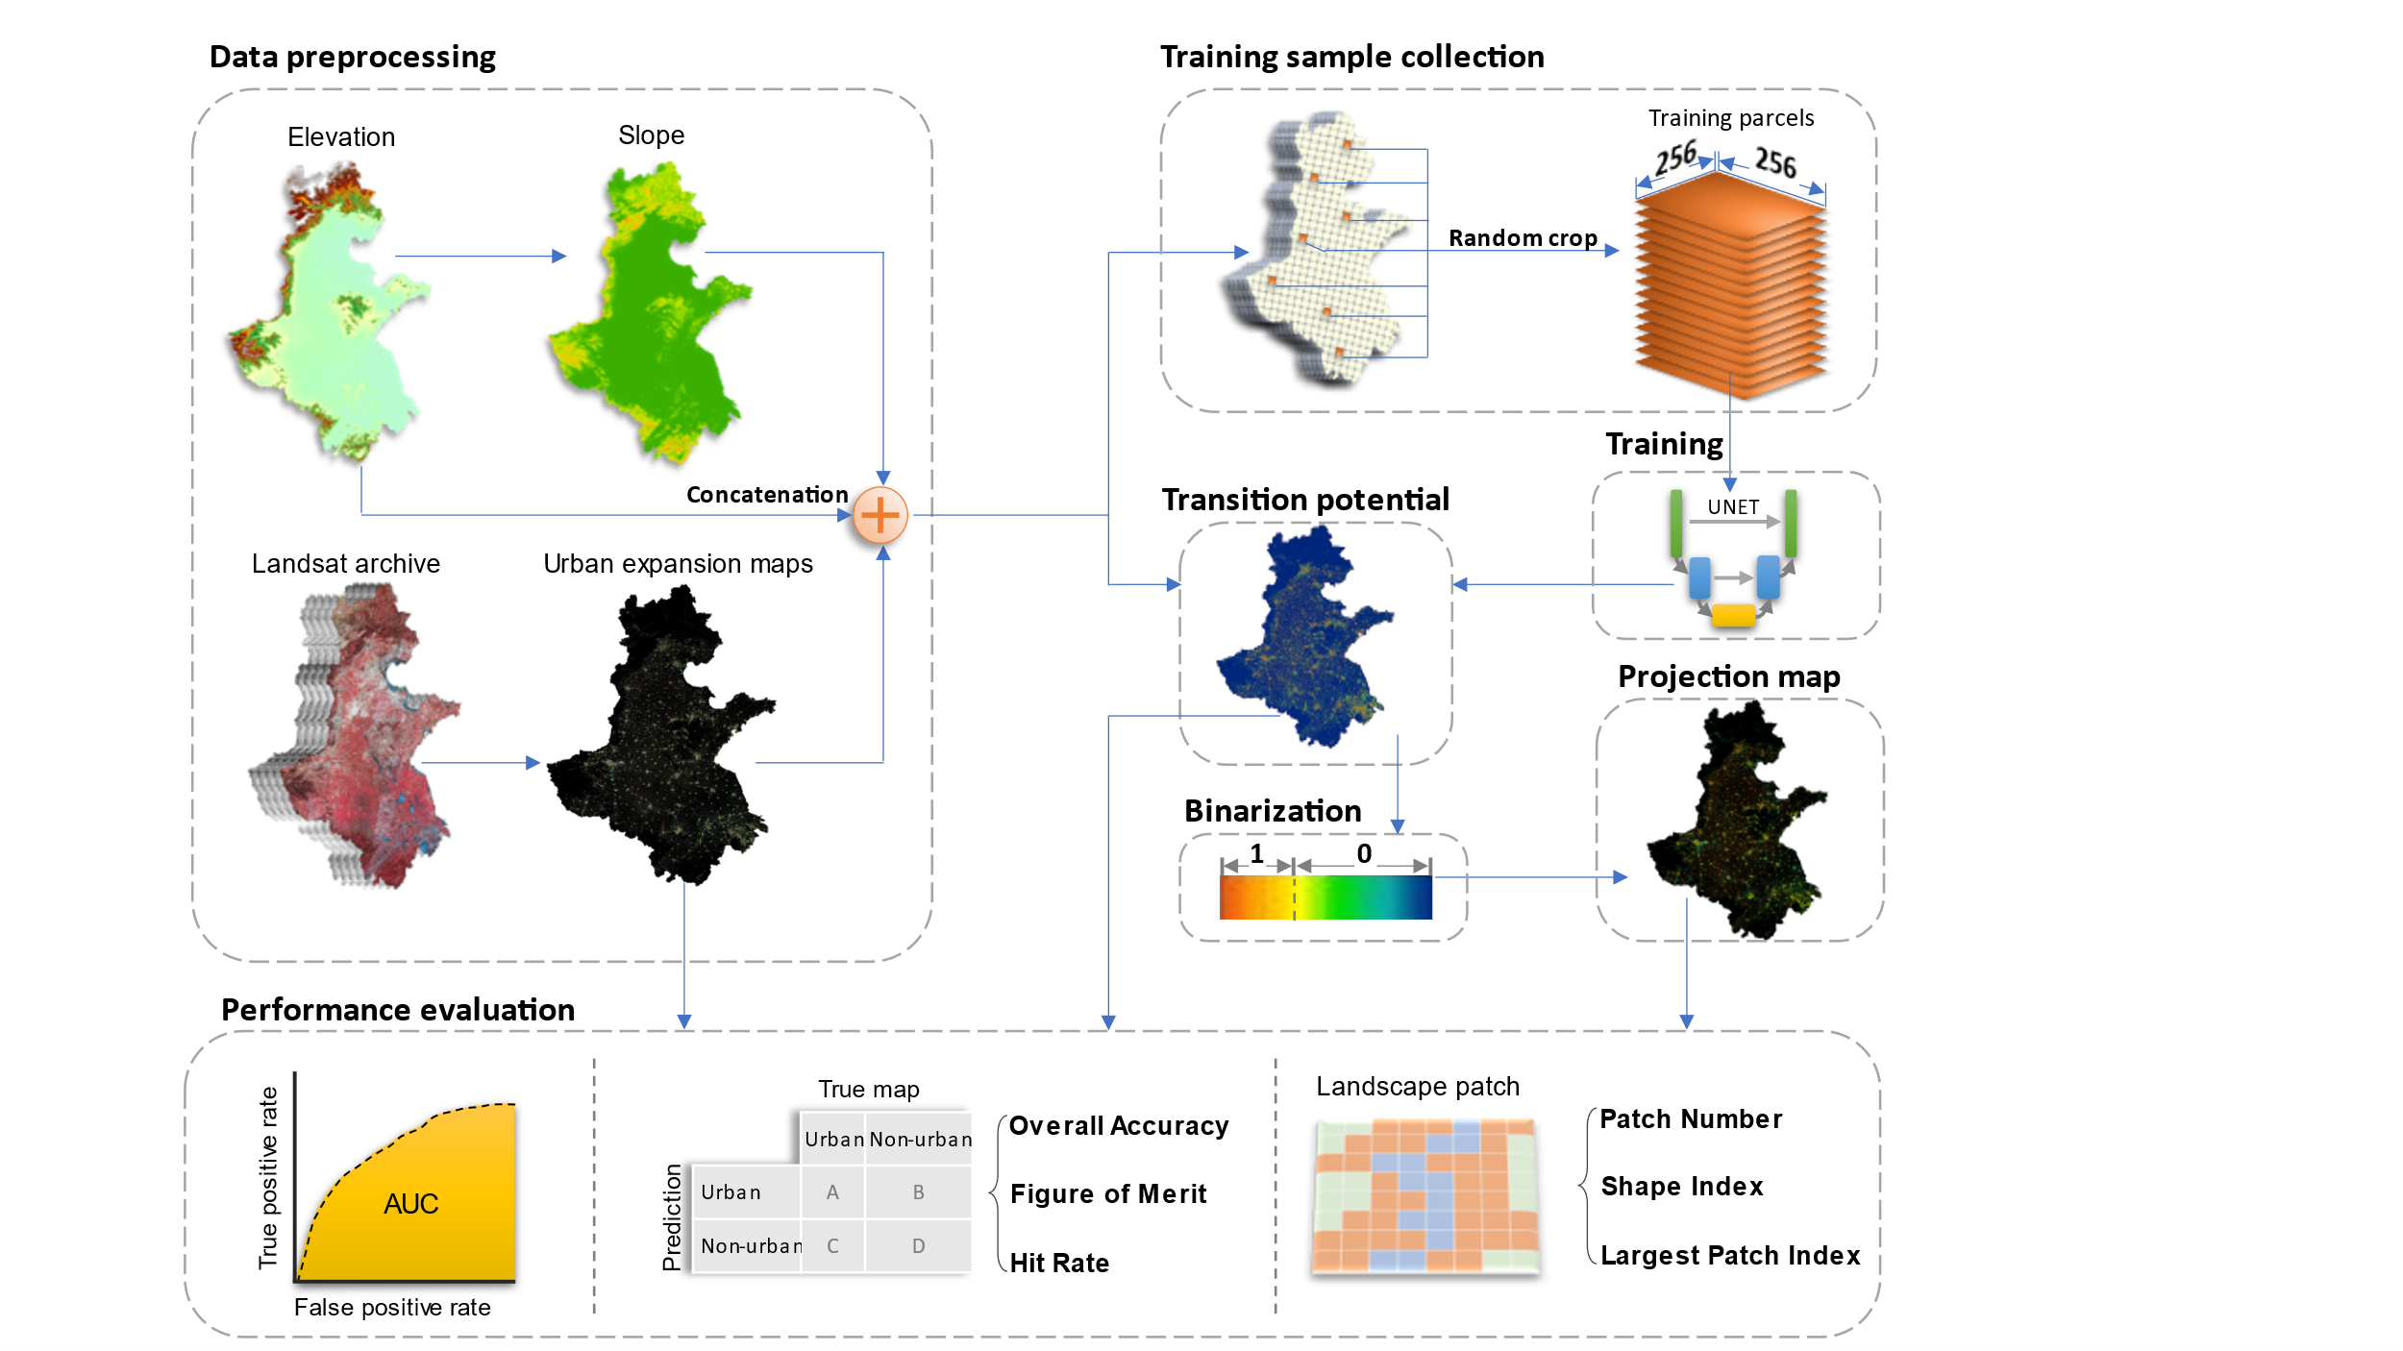

## 2.1 Study area



The study area (figure) includes 76 cities, spans over 780,000 km2 area, and homes to over >450 million people (ref). This area is one of the fastest urbanized regions in China that have tripled the built-up land coverage rate from ~5% in 1990 to ~15% in 2020 (ref). This region is crucial to China’s economic development and holds a strategic role to safeguard China’s food security because over one-third of the national gross domestic product and grain supply was generated there(ref). The tension between urbanization and farmland conservation in the study area requires accurate and spatial-explicit understandings for future urban development to address the challenges of food security, environmental protection, and urbanization.

## 2.2 Data preprocessing

The raster data used in this study were summarized in table. The urban dynamics maps were obtained from (paper-1, figure). This product spanned from 1990 to 2019 with three-year intervals and had a consistently high accuracy of > 94% across years because the use of temporal features successfully delineates urban land from fallow cropland and a further consistent check removed unreasonable urban developments (ref). The DEM was obtained from the Shuttle Radar Topography Mission (SRTM) and the slope data was derived from the DEM. The DEM and slope were used to assist the UNET to learn urban development patterns in complicated topology conditions, which have been proven effective in previous studies (ref).

|  |  |  |  |
| --- | --- | --- | --- |
| **Data Type** | **Source** | **Resolution** | **Time** |
| Urban dynamics | Wang et. al. | 30m | 1990-2019 |
| DEM | SRTM | 30m | 2000 |
| Slope | Derived from DEM | 30m | 2000 |

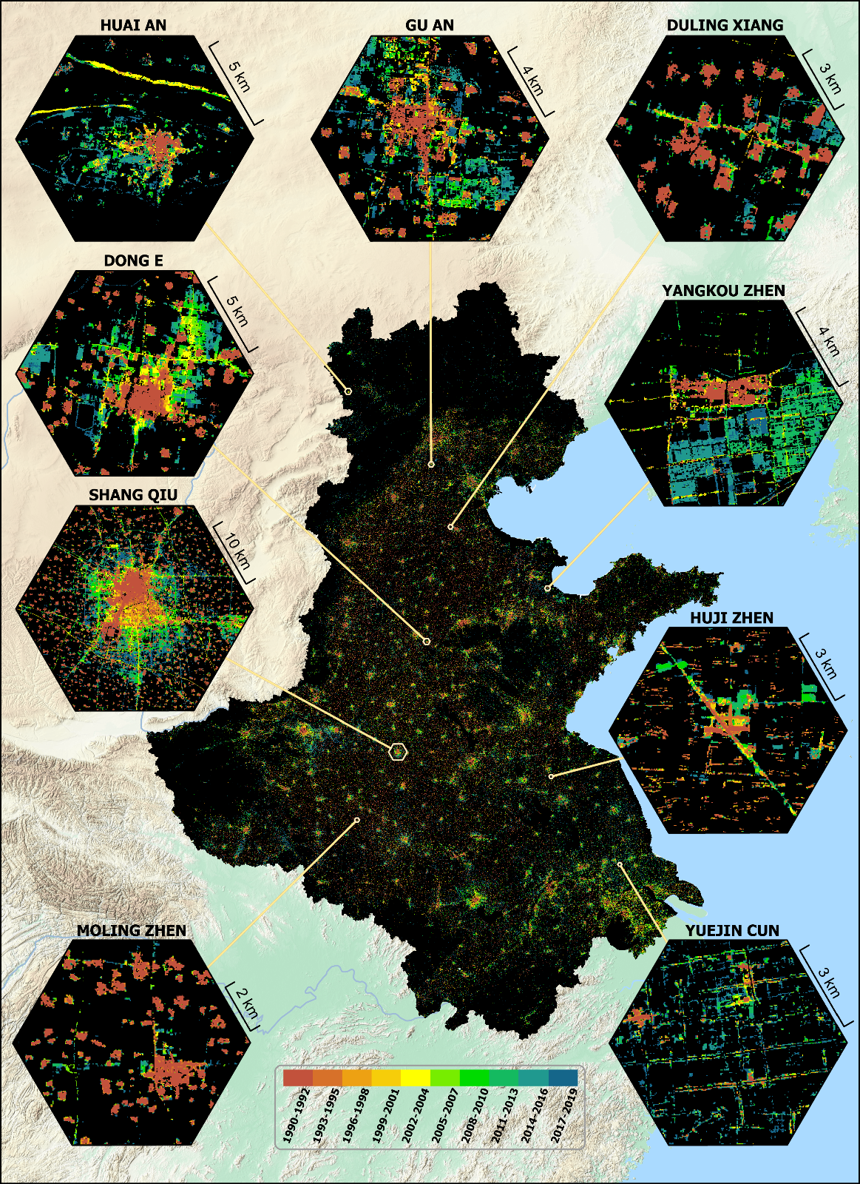

## 2.3 Control sample collection

Control samples were collected at the Google Earth Engine platform for its powerful cloud computation advantages (ref). The *neighborhoodToArray* module was used to randomly crop tiled image samples from the training image. We set the neighborhood size to 256 following common data science practices (ref) and collected 25,000 samples, of which 20,000 were used for the model training and the rest 5,000 for validation.

## 2.4 Training the UNET

The UNET was trained on tiled images of 256 × 256 pixels (fig). Each training image tile includes 3-layer input data (an urban map of 1993-1995, a DEM, and a slope map) and a single-layer target image (an urban map of 2005-2007). The 3-layer image tiles, during training, will be transformed to the size of 8 × 8 pixels after 5 down-sampling (i.e., max pooling with kernel size and stride of two) processes, and then converted to a single-layer output image that was the same size of 256 × 256 pixels to the input image tile with another 5 up-sampling (i.e., transpose convolution with kernel size and stride to be two) operations. The mean squared error (MSE) was used to measure the difference between the output image and the target image. A total of > 31 million parameters were involved in the training process and the derivative of each parameter to the MSE was computed via a backpropagation process. The parameters were updated according to their derivatives using the Adam algorithm (the learning was 0.001, beta-1 to be 0.9, and beta-2 to be 0.99). We iterated the training process for 200 epochs (an epoch refers to the UNET has updated its parameters using all 20,000 training samples) and computed the MSE validation samples to find the best model parameters.



## 2.5 Producing the transition potential map

The base image was split into image tiles, then supplied to the trained UNET to produce separate outputs, and then the outputs were mosaiced into a single transition potential map. The pixel values of this map ranged from 0 to 1 indicating the probability to be an urban pixel in the projection date. To reduce the “edge effect”, the image tiles were cropped at the size of 320 × 320 pixels that supplied with a 32-pixel buffer at each edge that will be removed after being processed by the UNET. Note although the UNET was trained on image tiles of 256 × 256 pixels, it can be applied to the buffered image tiles of 320 × 320 pixels (ref).



## 2.6 Producing the projection map

The projection map was created by binarizing the transition potential map. We computed the pixel counts of the transition potential map at an interval of 0.0001 and accumulated these pixel counts descended. The binarizing threshold was determined to be the accumulation value that was the closest to the urban pixel count in the projection year. Then the pixels in the transition potential map that were greater than the binarizing threshold were allocated to value 1 indicating urban lands in the projection year, other pixels were allocated with value 0 indicating non-urban pixels.

## 2.7 Validate the projection

The transition potential map was assessed using the area under the curve (AUC) of the ROC. The projection map was evaluated via map-overlay metrics and landscape metrics(ref). The map-overlay metrics selected in this study were overall accuracy (OA), the Hit rate, and the figure of merit (FoM). The landscape metrics selected in this study were patch number (PN), landscape shape index (LSI), and larget patch index (LPI). The equations and explanations for selected metrics were in table.

|  |  |  |
| --- | --- | --- |
| Name | Equation | Explanation |
| AUC | $$\int_{x=0}^{1}{TPR({FPR}^{-1}(x))dx}$$ | A measure of aggregated classifications that reflects the model’s sensitivity under different thresholds (ref). |
| OA | (A + D) / (A + B + C +D) | Measure a model’s overall performance on both positive and negative predictions (ref). |
| Hit rate | A / (A + C) | Measure a model’s predictive performance on the true positive outputs. |
| FoM | A / (A + B + C) | Measure a model’s performance on the true positive outputs from both the prediction and actual perspective. |
| PN | *n* | Reflect the fragmentation of a given landscape. |
| LSI | $$\frac{\sum{p_{i}}}{4\sqrt{\sum{a_{i}}}}$$ | Reflect the complexity of a given landscape. For example, a squared patch is deemed as simple (low value) whereas a linear patch is a complex (high value). |
| LPI | $$\frac{max⁡(a_{i})}{\sum{a_{i}}}$$ | Reflect the dominance of the largest patch to the total landscape area. |

Note, TPR is the true positive rate, FPR is the false positive rate of the ROC from the transition potential map. A refers to correctly predicted urban pixels (hit), B refers to the incorrectly predicted urban pixels (false alarm), C is the incorrectly predicted non-urban pixels (miss), and D is the correctly predicted non-urban pixels (correct rejection). $p_{i}$ is the perimeter (m) of the *i*th path of the urban patches, $a_{i}$ is the area (hectare) of the *i*th patch of the urban patches.

# 3. Result

## 3.1 Model training

The MSE of the UNET trained on the urban images of 1993-1995 and 2005-2007 was shown in fig. The MSE was decreasing first and then increased continuously. The lowest MSE was ~0.022 at the 70th epoch, which was selected as the best model to produce the predicted urban map of 2017-2019.



A randomly picked image tile was used to represent the UNET’s processing on input data, and the last activation map of each layer was used to visualize the learned capability of this layer (fig). The down-1 layer had learned to distinguish urban and non-urban pixels. The down-2 layer had learned to recognize simple patterns: the horizontal and vertical roads were highlighted in the activation map, and larger towns were pushed out among small villages. The down-3 layer had learned to associate adjacent urban clusters: potential urban development corridors were developed to connect discreet towns/villages. The down-4 layer had learned to allocate higher urban development probability to the pixels near existing towns/villages, making the urban development corridors more concentrated and intensive than the down-3 layer. The bottleneck layers were looking for general patterns that reflect the most possible urban development areas. The up-layers were learned to refine its former layer using the information from the down-layers: the up-4 layer had refined the bottleneck layer by assimilating the bottleneck layer and the down-4 layer; the up-3 layer further polished the up-4 layer using the pattern of “urban development corridors” identified in the down-3 layer. At last, the up-1 layer combined the urban/non-urban activation maps generated in the down-1 layer with refined patterns from the up-2 layer, and produced the final output image tile that allocated more urban pixels around bigger towns and maintain a refined pattern as well.

**Down-1**

**Down-2**

**Down-3**

**Down-4**

**Bottleneck**

**Up-4**

**Up-3**

**Up-2**

**Up-1**



Urban extent

DEM

Slope



**Input image tile**

**Output image tile**

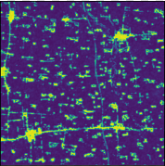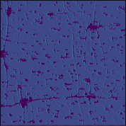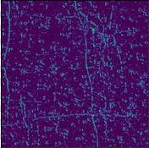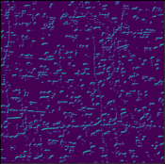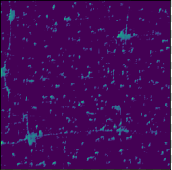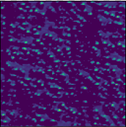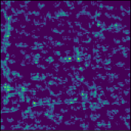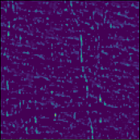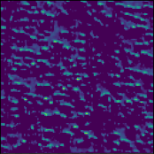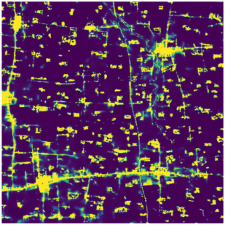

## 3.2 Transition potential

The transition potential map was shown in fig. The pixels near large towns and cities were more easily been allocated with higher transition potential value than small villages. For example, a large chunk of pixels surrounding Gu`An town were highlighted with high transition potential values, while only thin edges of nearby villages were identified as prone to urban in the future. Similar patterns were shown in Shangqiu at a large scale. The linear structures were well captured in the transition potential map. For example, the roads in Moling town and Yuejin village were identified despite there were only discreet roads segments in the original urban map.

## 3.3 Prediction validation

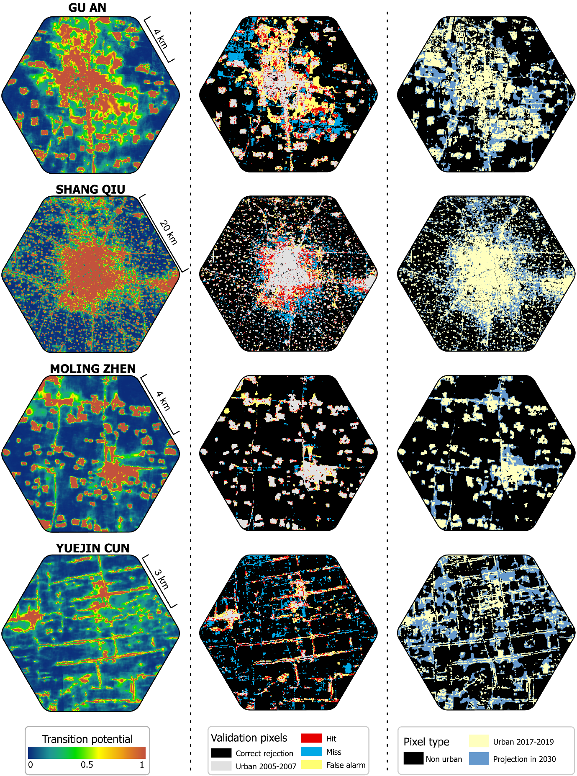

## 3.4 Accuracy



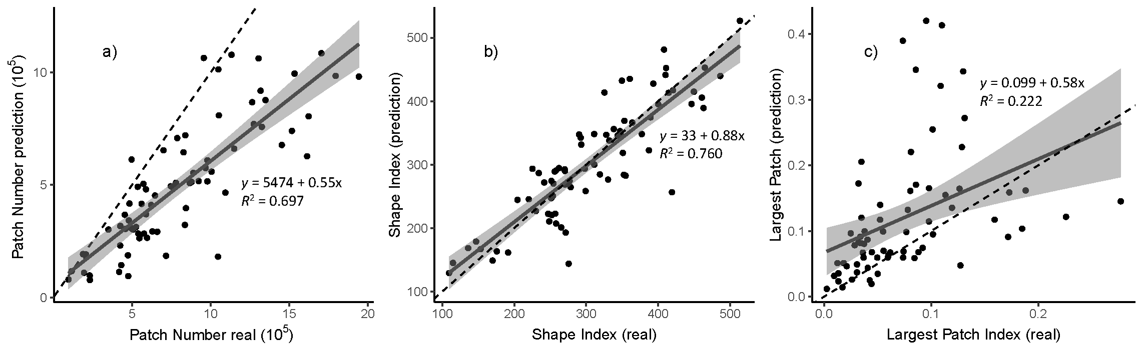

## 3.5 Prediction

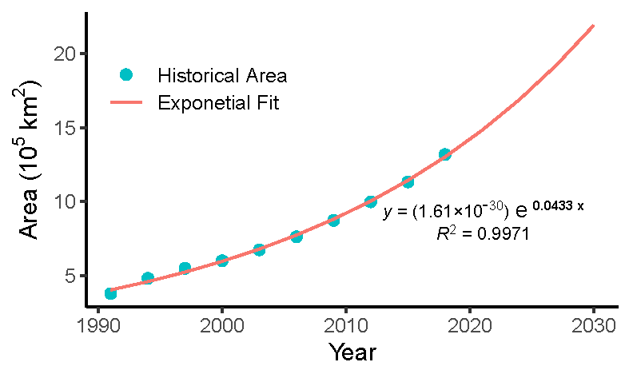

Publication bibliography

Carneiro, Murillo G.; Oliveira, Gina M. B. (2013): Synchronous cellular automata-based scheduler initialized by heuristic and modeled by a pseudo-linear neighborhood. In *Nat Comput* 12 (3), pp. 339–351. DOI: 10.1007/s11047-013-9375-8.

Chu, Andrea; Lin, Ying-Chen; Chiueh, Pei-Te (2017): Incorporating the effect of urbanization in measuring climate adaptive capacity. In *Land use policy* 68, pp. 28–38. DOI: 10.1016/j.landusepol.2017.07.019.

Clarke, Keith C.; Johnson, J. Michael (2020): Calibrating SLEUTH with big data: Projecting California's land use to 2100. In *Computers, Environment and Urban Systems* 83, p. 101525. DOI: 10.1016/j.compenvurbsys.2020.101525.

Gantumur, Byambakhuu; Wu, Falin; Vandansambuu, Battsengel; Tsegmid, Bazarkhand; Dalaibaatar, Enkhjargal; Zhao, Yan (2020): Spatiotemporal dynamics of urban expansion and its simulation using CA-ANN model in Ulaanbaatar, Mongolia. In *Geocarto International*, pp. 1–16. DOI: 10.1080/10106049.2020.1723714.

Goodchild, Michael F. (2004): The Validity and Usefulness of Laws in Geographic Information Science and Geography. In *Annals of the Association of American Geographers* 94 (2), pp. 300–303. DOI: 10.1111/j.1467-8306.2004.09402008.x.

Kalnay, Eugenia; Cai, Ming (2003): Impact of urbanization and land-use change on climate. In *Nature* 423 (6939), pp. 528–531. DOI: 10.1038/nature01675.

Li, Xuecao; Gong, Peng; Le Yu; Hu, Tengyun (2017): A segment derived patch-based logistic cellular automata for urban growth modeling with heuristic rules. In *Computers, Environment and Urban Systems* 65, pp. 140–149. DOI: 10.1016/j.compenvurbsys.2017.06.001.

Lin, Jingyu; Huang, Jinliang; Prell, Christina; Bryan, Brett A. (2021): Changes in supply and demand mediate the effects of land-use change on freshwater ecosystem services flows. In *The Science of the total environment* 763, p. 143012. DOI: 10.1016/j.scitotenv.2020.143012.

Mansour, Shawky; Al-Belushi, Mohammed; Al-Awadhi, Talal (2020): Monitoring land use and land cover changes in the mountainous cities of Oman using GIS and CA-Markov modelling techniques. In *Land use policy* 91, p. 104414. DOI: 10.1016/j.landusepol.2019.104414.

Mustafa, Ahmed; Heppenstall, Alison; Omrani, Hichem; Saadi, Ismaïl; Cools, Mario; Teller, Jacques (2018): Modelling built-up expansion and densification with multinomial logistic regression, cellular automata and genetic algorithm. In *Computers, Environment and Urban Systems* 67, pp. 147–156. DOI: 10.1016/j.compenvurbsys.2017.09.009.

Prayitno, Gunawan (2020): Land-use prediction in Pandaan District pasuruan regency. In *GEOMATE* 18 (65). DOI: 10.21660/2020.65.41738.

Qian, Yuehui; Xing, Weiran; Guan, Xuefeng; Yang, Tingting; Wu, Huayi (2020): Coupling cellular automata with area partitioning and spatiotemporal convolution for dynamic land use change simulation. In *The Science of the total environment* 722, p. 137738. DOI: 10.1016/j.scitotenv.2020.137738.

Qiu, Tong; Song, Conghe; Zhang, Yulong; Liu, Hongsheng; Vose, James M. (2020): Urbanization and climate change jointly shift land surface phenology in the northern mid-latitude large cities. In *Remote Sensing of Environment* 236, p. 111477. DOI: 10.1016/j.rse.2019.111477.

Qiu, Xin (2020): China 40 years infrastructure construction. Singapore: Springer (Research series on the Chinese dream and China's development path, 2363-6866).

Roodposhti, Majid Shadman; Hewitt, Richard J.; Bryan, Brett A. (2020): Towards automatic calibration of neighbourhood influence in cellular automata land-use models. In *Computers, Environment and Urban Systems* 79, p. 101416. DOI: 10.1016/j.compenvurbsys.2019.101416.

Ruiz Hernandez, Ivan Elias; Shi, Wenzhong (2018): A Random Forests classification method for urban land-use mapping integrating spatial metrics and texture analysis. In *International Journal of Remote Sensing* 39 (4), pp. 1175–1198. DOI: 10.1080/01431161.2017.1395968.

Tobler, W. R. (1970): A Computer Movie Simulating Urban Growth in the Detroit Region. In *Economic Geography* 46, p. 234. DOI: 10.2307/143141.

Tong, Xiaohua; Feng, Yongjiu (2020): A review of assessment methods for cellular automata models of land-use change and urban growth. In *International Journal of Geographical Information Science* 34 (5), pp. 866–898. DOI: 10.1080/13658816.2019.1684499.

Tzaninis, Yannis; Mandler, Tait; Kaika, Maria; Keil, Roger (2021): Moving urban political ecology beyond the 'urbanization of nature'. In *Progress in human geography* 45 (2), pp. 229–252. DOI: 10.1177/0309132520903350.

Wang, Haijun; Guo, Jiaqi; Zhang, Bin; Zeng, Haoran (2021): Simulating urban land growth by incorporating historical information into a cellular automata model. In *Landscape and Urban Planning* 214, p. 104168. DOI: 10.1016/j.landurbplan.2021.104168.

Xia, Chang; Zhang, Bin (2021): Exploring the effects of partitioned transition rules upon urban growth simulation in a megacity region: a comparative study of cellular automata-based models in the Greater Wuhan Area. In *GIScience & Remote Sensing*, pp. 1–24. DOI: 10.1080/15481603.2021.1933714.

Yue, Huanbi; He, Chunyang; Huang, Qingxu; Yin, Dan; Bryan, Brett A. (2020): Stronger policy required to substantially reduce deaths from PM2.5 pollution in China. In *Nature communications* 11 (1), p. 1462. DOI: 10.1038/s41467-020-15319-4.

Zhai, Yaqian; Yao, Yao; Guan, Qingfeng; Liang, Xun; Li, Xia; Pan, Yongting et al. (2020): Simulating urban land use change by integrating a convolutional neural network with vector-based cellular automata. In *International Journal of Geographical Information Science* 34 (7), pp. 1475–1499. DOI: 10.1080/13658816.2020.1711915.